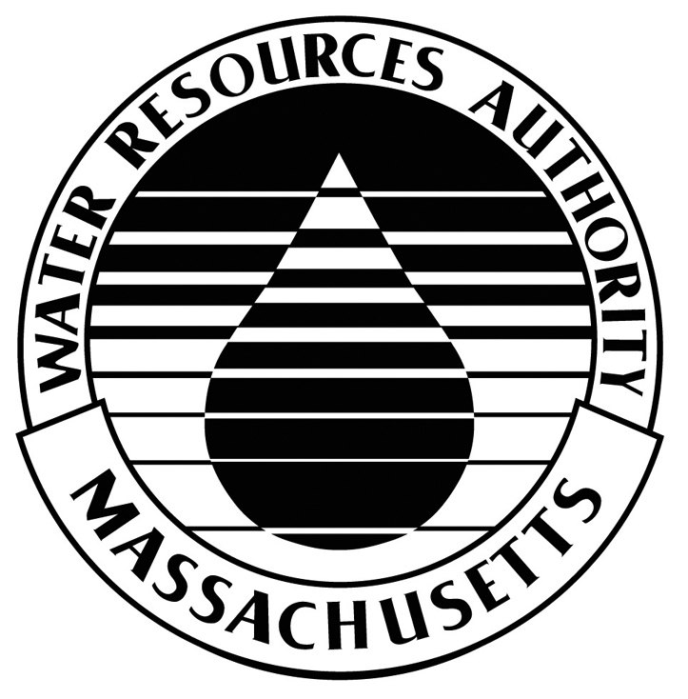
MASSACHUSETTS WATER RESOURCES AUTHORITY

APPLICATION FOR 8(m) PERMIT

=================================================================
What is this application and why is it necessary?

This application, when completed and submitted, requests the MWRA to issue an 8(m) Permit. Section 8(m) of chapter 372 of the Acts of 1984 enables the Authority to issue permits to other entities to build, construct, excavate, or cross within an easement or other property interest held by the Authority.

How to complete and submit this application?

Please print legibly in black or dark blue ink or type all responses. Answer all questions: if a question does not apply to your project, write “Not Applicable” or “N/A”. Include all necessary documents. Keep a copy of the completed application for your records.

Send a $100.00 non-refundable check for the administrative processing fee, the original and five (5) copies of the completed application and any other required documents to either:

Massachusetts Water Resources Authority
Wastewater 8(m) Permitting Unit
2 Griffin Way

Chelsea, MA 02150
Attn: Kevin McKenna

Or
Massachusetts Water Resources Authority
Waterworks 8(m) Permitting Unit
2 Griffin Way
Chelsea, MA 02150
Attn: Ralph A. Francesconi
Permit Process:
- The owner of the work, project, property or facilities that are resulting in the need for this 8m permit must be the party signing the permit application (not the project contractor or consultant).
- MWRA staff will review the application to determine if your request can be approved. If MWRA cannot issue the requested permit, you will receive a letter explaining the reasons for denying the request.
- If the permit application is approved, MWRA staff will send you three original 8(m) Permits for your signature. Additionally, a completed 8(m) Permit Assessment Fee Form noting any additional charges beyond the administrative processing fee (if required) will be sent.
- Upon receipt of all signed originals and payment for any additional fees, MWRA will execute the document.
- MWRA will mail the executed documents with a Notice to Proceed.
- All plans submitted shall be stamped by a Professional Engineer or Professional Land Surveyor licensed in the State of Massachusetts.
- All design, construction and excavation shall be conducted in accordance with all federal, state and local safety regulations including but not limited to federal OSHA regulations (29 CFR 1926) and Massachusetts Department of Public Safety regulations (520 CMR 14.00). During construction, appropriate sheeting and shoring measures must be taken to protect the integrity of the Authority’s water/ sewer mains. Any sheeting and shoring design must be submitted to MWRA prior to the start of the construction. The submitted design of excavation trench support and all temporary supports associated with excavating under or near MWRA water and sewer lines shall be stamped by a Professional Engineer, licensed in Massachusetts.

Questions and answers:
For answers to questions about this application and MWRA 8(m) Permits, contact MWRA’s Wastewater 8(m) Permitting Unit at (617) 305-5956 or MWRA’s Waterworks 8(m) Permitting Unit at (617) 305-5827.

MASSACHUSETTS WATER RESOURCES AUTHORITY
APPLICATION FOR 8(m) PERMIT

1. Applicant Owner Permit Issued To (Town or City, Utility Co. Owner of Property)

Name:

Mailing Address:

Telephone (include area code):

Email Address:

2. Person to contact about this application (if other than the applicant):

Name:

Mailing Address:

Telephone (include area code):

Email Address:

3. Location of the proposed work:

Street Address:

City/Town:

MWRA sewer line or waterline, section, nearest manhole:
Deed Book and Page or Land Court Certificate (if known):

4. Brief description of work to be performed:

Approximate Start Date: Estimated Completion Date:

5. Permits other than MWRA 8(m) Permit that need to be obtained before work can commence:

Please attach available plans and specifications of work to be performed and any other information that would be helpful in reviewing this application.

6. OTHER FILINGS

There are circumstances when the MWRA cannot issue a permit to you until you fulfill the requirements of another agency. This page asks for information about whether you are required to file with the Massachusetts Historical Commission (MHC) or under the Massachusetts Environmental Policy Act (MEPA) and the status of your filing, if any. If you have any questions about the requirements of those agencies, please contact them for information: MHC may be reached at 617-727-8470; the MEPA office may be reached at 617-727-5830.

- Is the activity for which you require an MWRA permit a part of a project that is likely to impact a geographic area and affect or cause a change in the historical, architectural, archeological, or cultural qualities of a property as defined by the Massachusetts Historical Commission (MHC)? (For example, answer “no” if this application is for a permit renewal or you are not doing new construction. MHC defines “new construction” as a modification to the land or any existing structure.) □Yes □No If “no,” skip question 2.

- If your answer to question 1 is “yes:”

- Have you provided the required project notification form (950 CMR 71, Appendix A) to the MHC? □Yes □No

- Briefly describe the status of the project with MHC. Provide documentation (see 950 CMR 71.07) allowing the MWRA to act on this application. If you have not provided notice to the MHC, explain why you have not provided notice and when you will provide notice.

- Is the activity for which you require an MWRA permit a part of a project that is subject to review under the Massachusetts Environmental Policy Act (MEPA)? (For example, answer “no” if this application is for a permit renewal or not part of a larger project. The MEPA review thresholds are found in 301 CMR 11.00.) □Yes □No If “no,” skip question 4.

- If your answer to question 3 is “yes:”

- Have you made the required MEPA filing? □Yes □No

- Briefly describe the status of the MEPA review. Provide documentation (see 301 CMR 11.10) allowing the MWRA to act on this application. If you have not filed with MEPA, explain why you have not filed and when you will file.

7. Applicant Certification:

I certify, under penalty of law, that this document and all attachments were prepared under my direction or supervision in accordance with a system designed to assure that qualified personnel properly gathered and evaluated the information submitted. Based on my inquiry of the person or persons who manage the system, or those persons directly responsible for gathering the information, the information submitted is to the best of my knowledge and belief, true, accurate, and complete. I am aware that there are significant penalties for submitting false information, including the possibility of fine and imprisonment for knowing violations.

Applicant’s Signature: Date:

Print the name of the person whose signature is above:

Corporate Title (if any):

